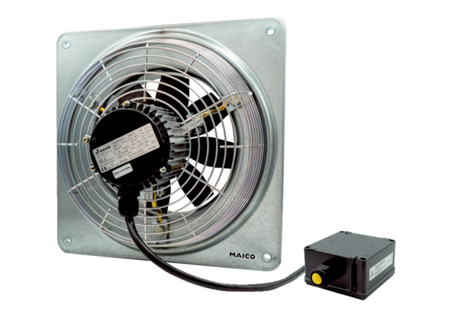Axial wall fan DZQ 30/6 B Ex ePacking unit: 1 pieceRange: C
Article number: 0083.0174Manufacturer: MAICO

