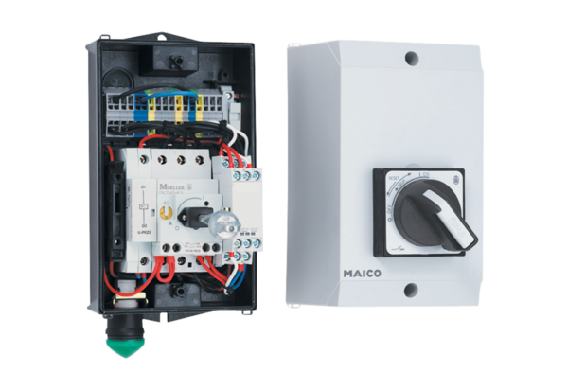PTC thermistor triggering device MVS 6Packing unit: 1 pieceRange: D
Article number: 0157.0585Manufacturer: MAICO

