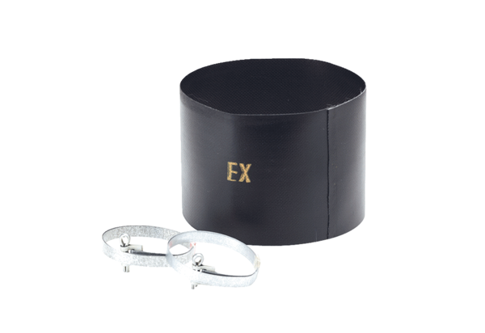Flexible cuff ELM 16 ExPacking unit: 1 pieceRange: C
Article number: 0092.0247Manufacturer: MAICO

