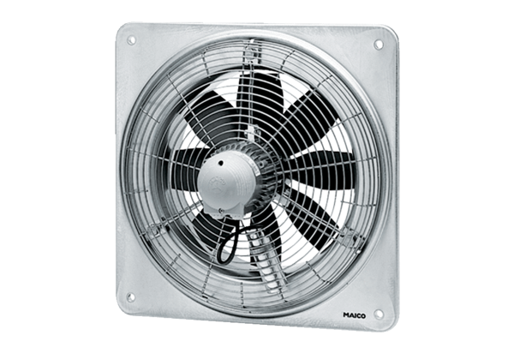Axial wall fan DZQ 40/126 BPacking unit: 1 pieceRange: C
Article number: 0083.0153Manufacturer: MAICO

