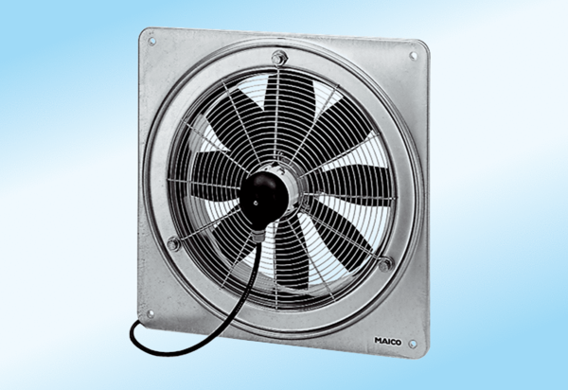Axial wall fan DZQ 50/6 A-ExPacking unit: 1 pieceRange: C
Article number: 0083.0785Manufacturer: MAICO

