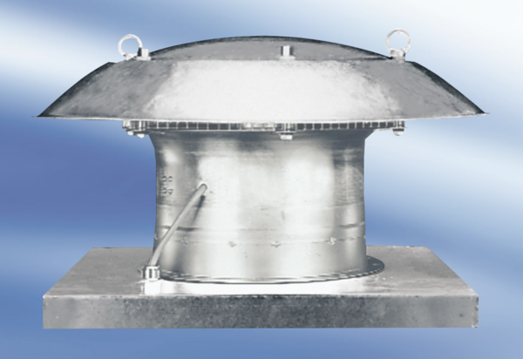Axial roof fan DZD 40/4 A-ExPacking unit: 1 pieceRange: C
Article number: 0087.0776Manufacturer: MAICO

