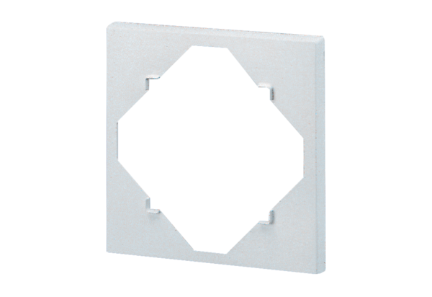Spacing frame DR 60/100Packing unit: 1 pieceRange: B
Article number: 0059.0928Manufacturer: MAICO

