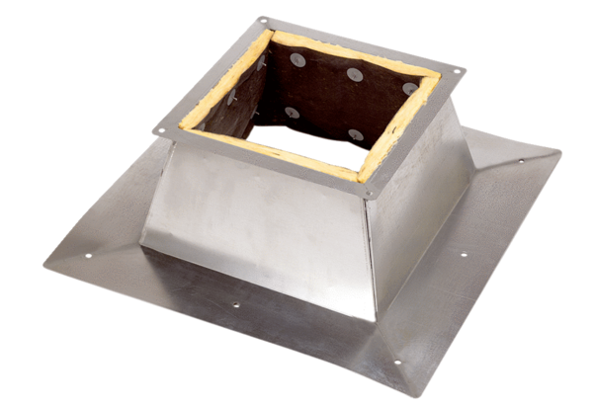Roof socket for flat roofs SO 25Packing unit: 1 pieceRange: C
Article number: 0093.0360Manufacturer: MAICO

