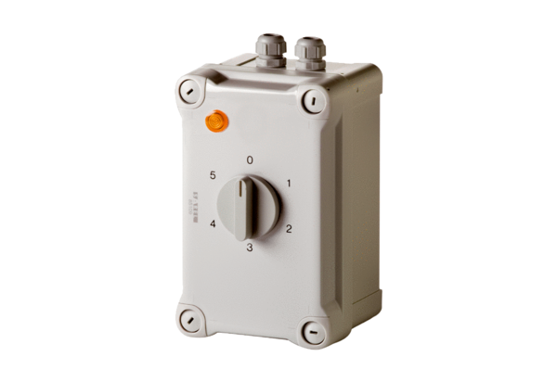5-step transformer TRE 3,3-1Packing unit: 1 pieceRange: C
Article number: 0157.0841Manufacturer: MAICO

