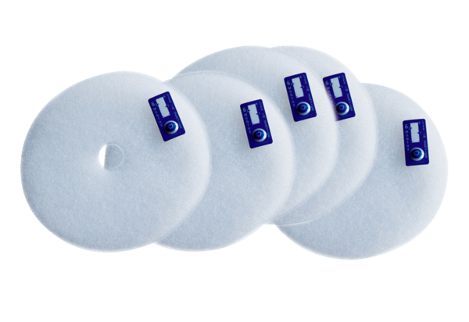Air filter, replacement ZF EC+Packing unit: 5 piecesRange: B
Article number: 0093.0610Manufacturer: MAICO

