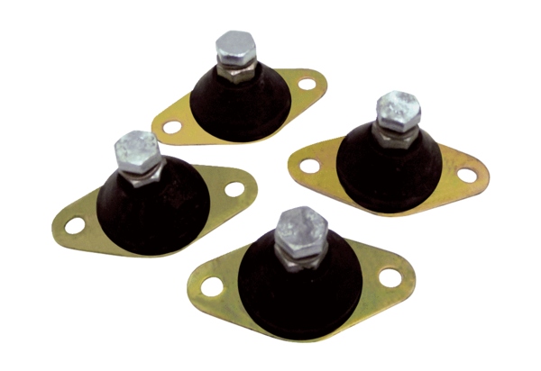Vibration damper GP 10Packing unit: 4 piecesRange: C
Article number: 0092.0151Manufacturer: MAICO

