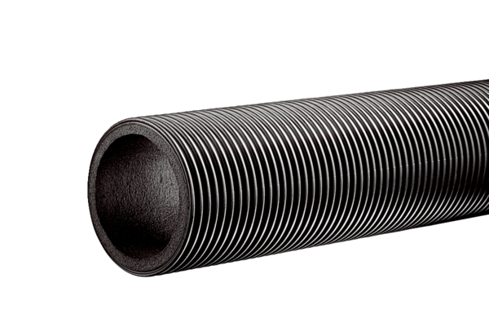Ventilation duct, thermally insulated MT-R125Packing unit: 2 mRange: K
Article number: 0059.0981Manufacturer: MAICO

