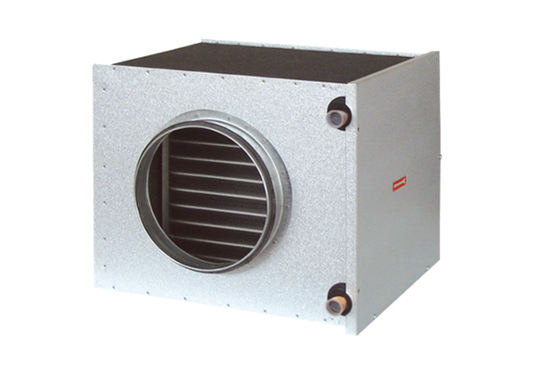Brine-air heat exchanger EW-K 160Packing unit: 1 pieceRange: K
Article number: 0192.0404Manufacturer: MAICO

