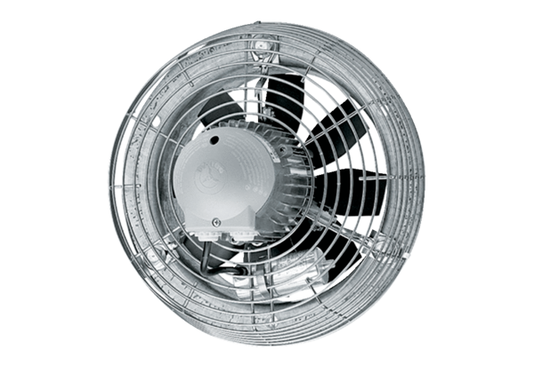Axial wall fan DZS 30/42 BPacking unit: 1 pieceRange: C
Article number: 0094.0044Manufacturer: MAICO

