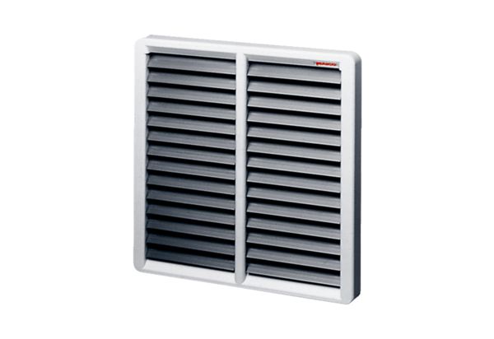Shutter, manual RS 40Packing unit: 1 pieceRange: C
Article number: 0151.0342Manufacturer: MAICO

