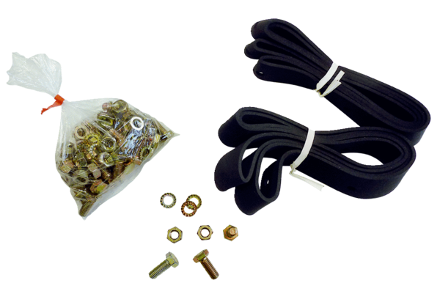Mounting and sealing material BD 35Packing unit: 1 pieceRange: C
Article number: 0092.0135Manufacturer: MAICO

