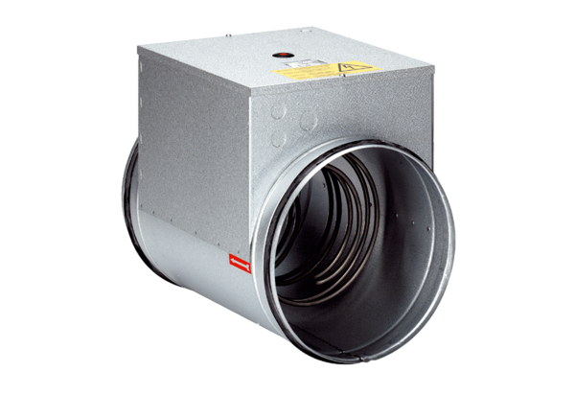Electrical air heater ERH 20-2Packing unit: 1 pieceRange: C
Article number: 0082.0103Manufacturer: MAICO

