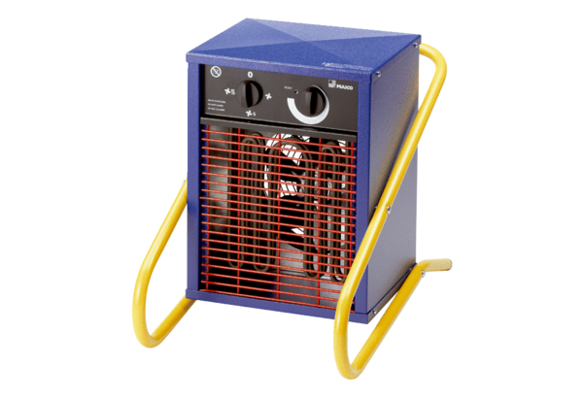Heater fan PHD 5Packing unit: 1 pieceRange: C
Article number: 0082.0066Manufacturer: MAICO

