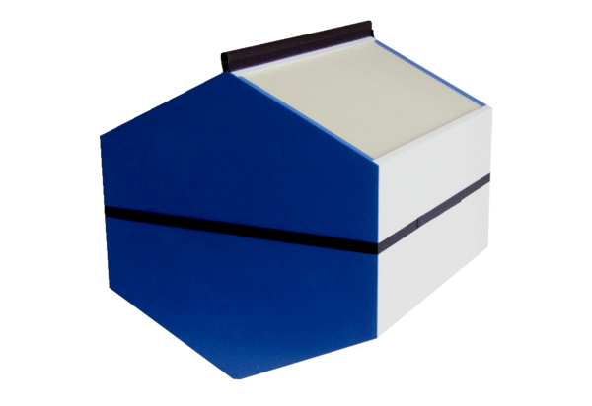Enthalpy heat exchanger WSET 250Packing unit: 1 pieceRange: K
Article number: 0192.0610Manufacturer: MAICO

