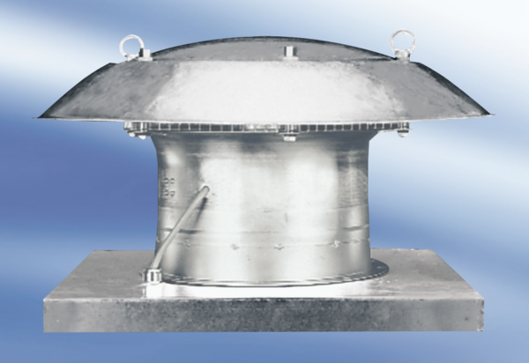Axial roof fan DZD 40/8 APacking unit: 1 pieceRange:
Article number: 0087.0420Manufacturer: MAICO

