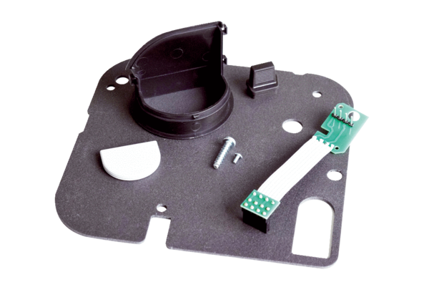Replacement kit ER-RPKPacking unit: 1 setRange: B
Article number: 0093.1563Manufacturer: MAICO

