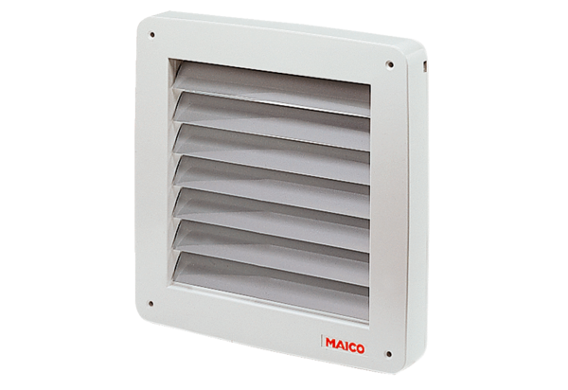Shutter, electric MK 31Packing unit: 1 pieceRange: C
Article number: 0093.0908Manufacturer: MAICO

