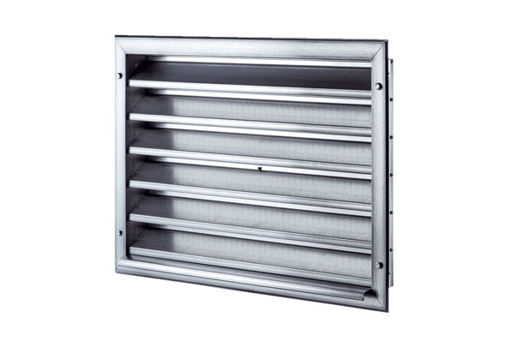External grille LZP 56Packing unit: 1 pieceRange: D
Article number: 0151.0315Manufacturer: MAICO

