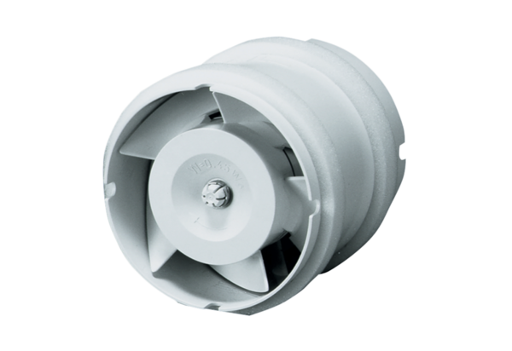Duct-mounted fan ECA 15/2 EPacking unit: 1 pieceRange: A
Article number: 0080.0990Manufacturer: MAICO

