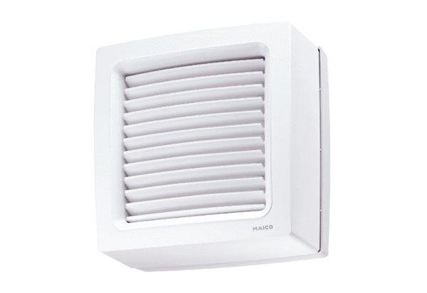Axial window fan EVN 15Packing unit: 1 pieceRange: C
Article number: 0080.0853Manufacturer: MAICO

