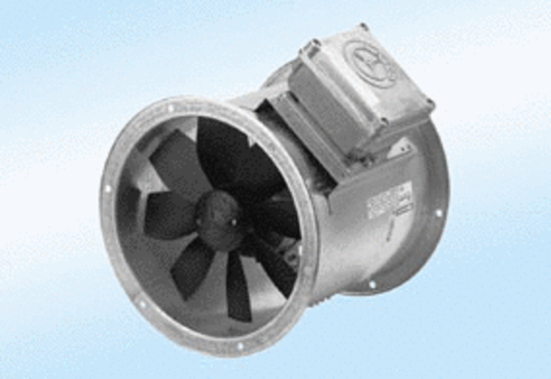Axial duct fan DZR 45/4 A-ExPacking unit: 1 pieceRange: C
Article number: 0086.0781Manufacturer: MAICO

