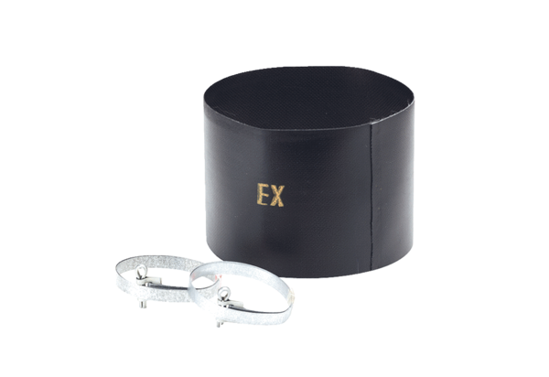Flexible cuff ELM 15 ExPacking unit: 1 pieceRange: C
Article number: 0092.0244Manufacturer: MAICO

