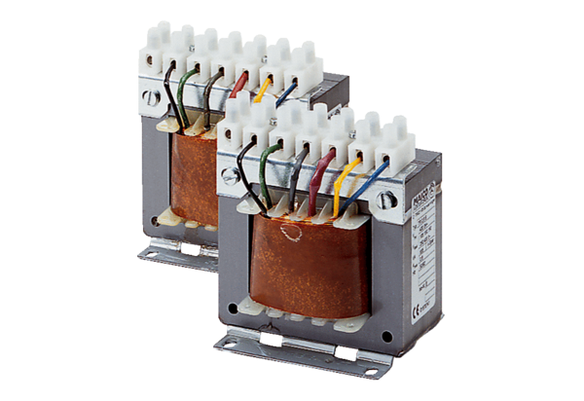5-step transformer, control cabinet TR 2,5 SPacking unit: 1 pieceRange: C
Article number: 0157.0742Manufacturer: MAICO

