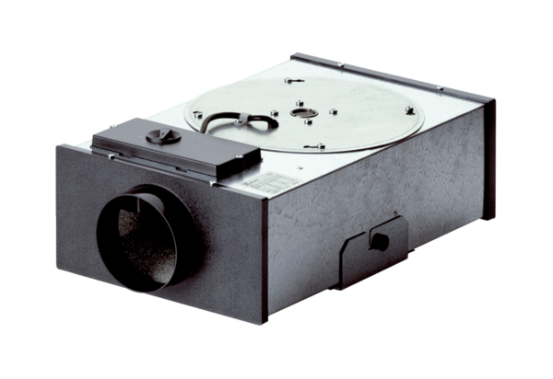Centrifugal flat box EFR 10Packing unit: 1 pieceRange: C
Article number: 0080.0570Manufacturer: MAICO

