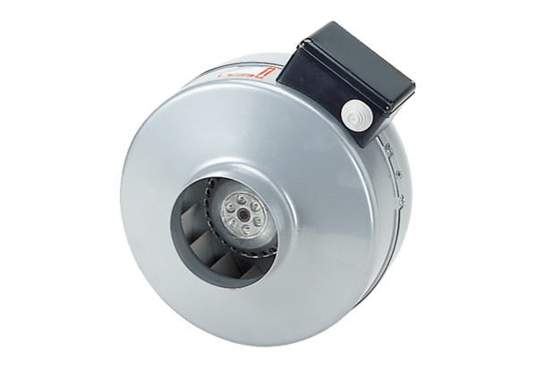Centrifugal duct fan ERR 12/1Packing unit: 1 pieceRange: C
Article number: 0080.0272Manufacturer: MAICO

