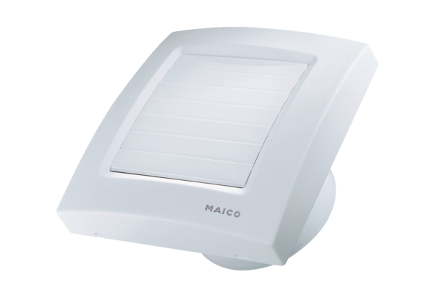Small room fan ECA 100 KVZCPacking unit: 1 pieceRange: A
Article number: 0084.0041Manufacturer: MAICO

