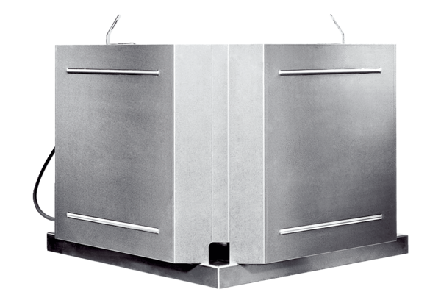Centrifugal roof fan DRD 22 ECPacking unit: 1 pieceRange: E
Article number: 0087.0171Manufacturer: MAICO

