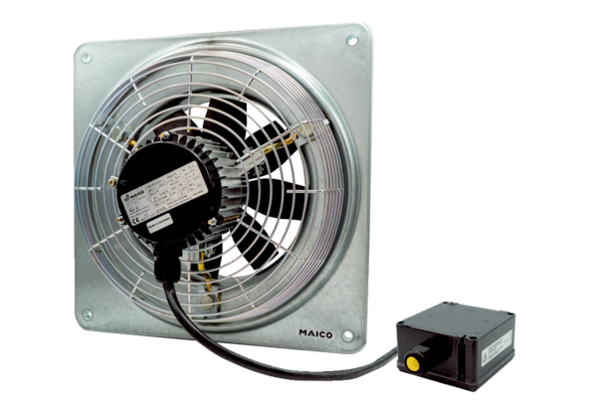Axial wall fan EZQ 20/4 E Ex ePacking unit: 1 pieceRange: C
Article number: 0083.0850Manufacturer: MAICO

