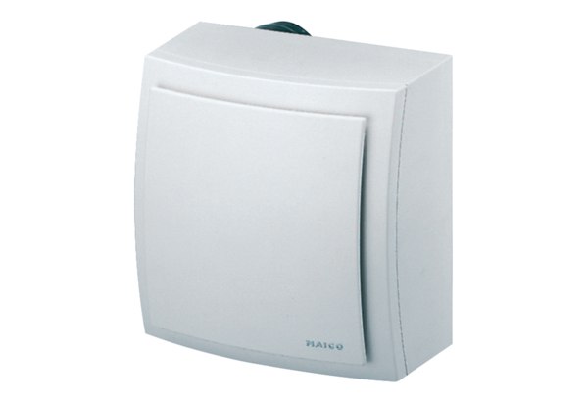Surface-mounted fan ER-AP 100 HPacking unit: 1 pieceRange: B
Article number: 0084.0174Manufacturer: MAICO

