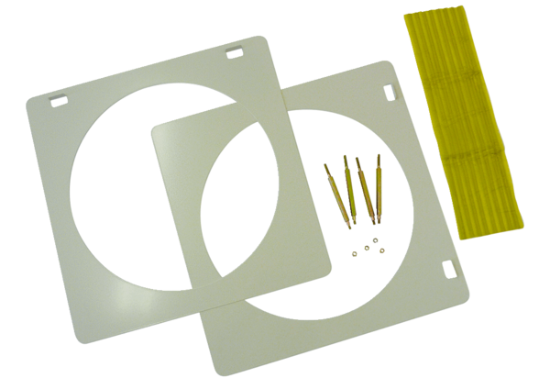Accessories for glass brick walls ZG 31Packing unit: 1 pieceRange: C
Article number: 0093.0158Manufacturer: MAICO

