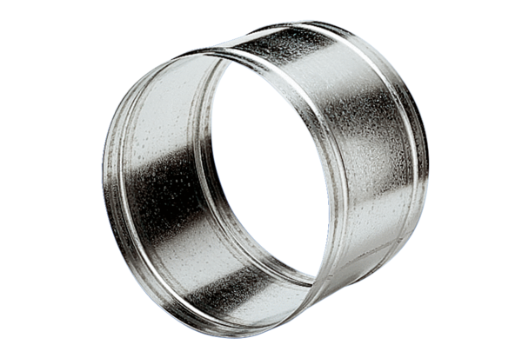Extension sleeve VH 31Packing unit: 1 pieceRange: C
Article number: 0055.0037Manufacturer: MAICO

