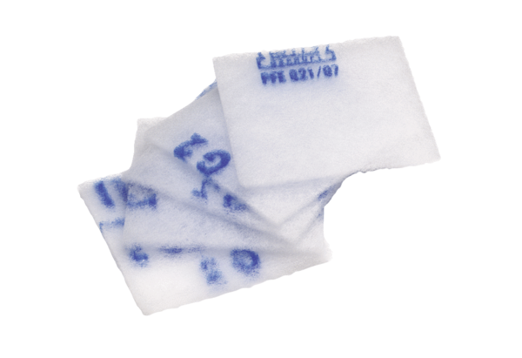Air filter, replacement SF 120Packing unit: 5 piecesRange: A
Article number: 0093.0925Manufacturer: MAICO

