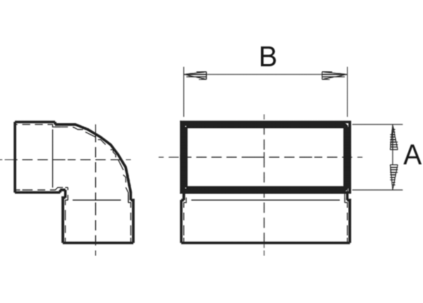90° channel elbows, short, vertical KB90KV/70/170Packing unit: 1 pieceRange: K
Article number: 0055.0596Manufacturer: MAICO

