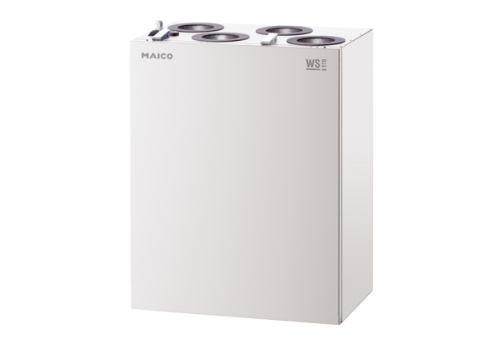Centralised ventilation unit WS 170 RPacking unit: 1 pieceRange: K
Article number: 0095.0081Manufacturer: MAICO

