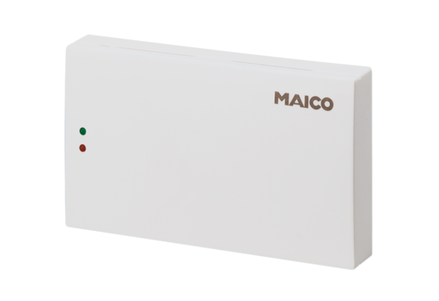Air quality controller EAQ 10/1Packing unit: 1 pieceRange: C
Article number: 0157.0777Manufacturer: MAICO

