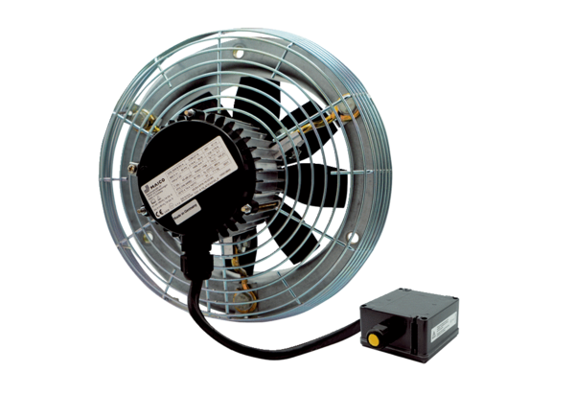Axial wall fan DZS 60/6 B Ex ePacking unit: 1 pieceRange: C
Article number: 0094.0130Manufacturer: MAICO

