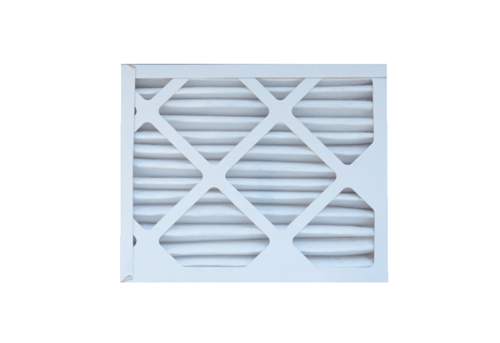Air filter, replacement ECR 12-20 EC M5Packing unit: 1 pieceRange: E
Article number: 0093.1523Manufacturer: MAICO

