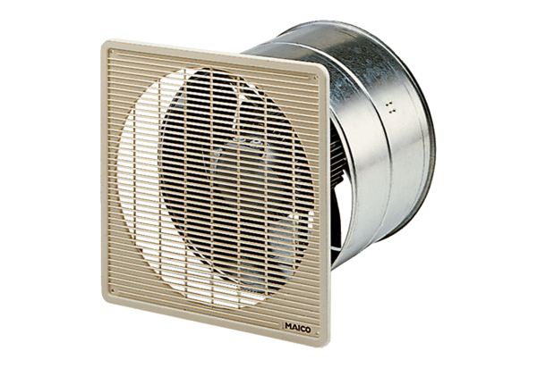DZF 40/8 BPacking unit: 1 pieceRange: C
Article number: 0085.0105Manufacturer: MAICO

