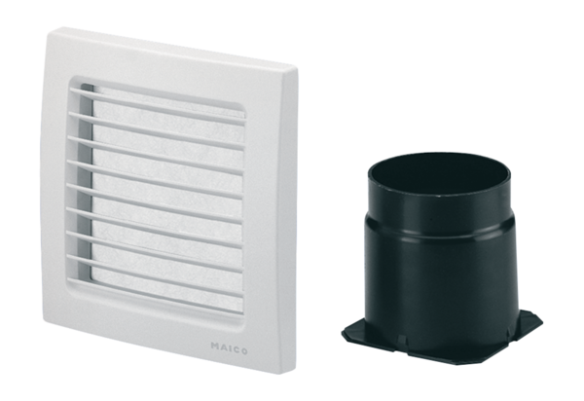Second room extraction system ER-ZRPacking unit: 1 pieceRange: B
Article number: 0093.1025Manufacturer: MAICO

