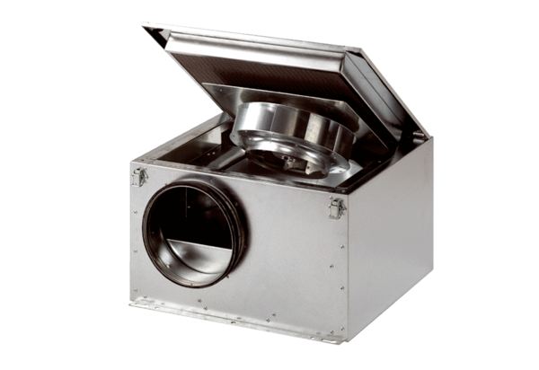Sound-insulated ventilation box DSR 35 SPacking unit: 1 pieceRange: C
Article number: 0080.0232Manufacturer: MAICO

