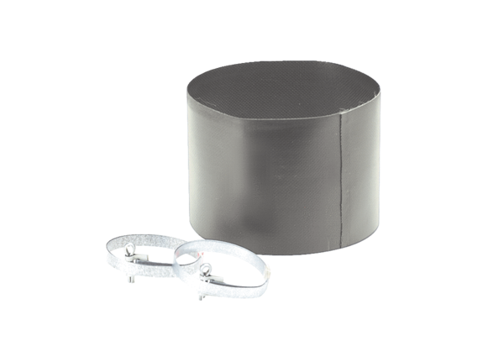Flexible cuff ELM 12Packing unit: 1 pieceRange: C
Article number: 0092.0122Manufacturer: MAICO

