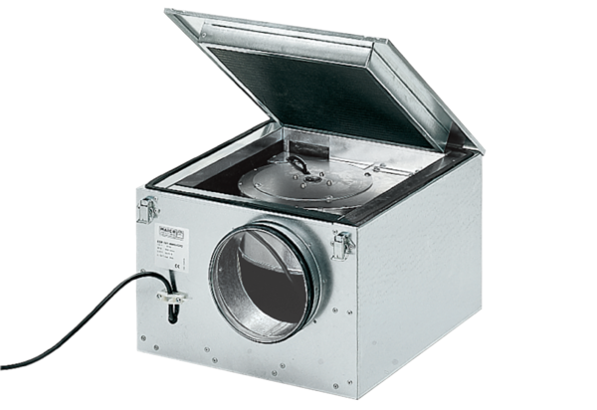Sound-insulated ventilation box ESR 40/1Packing unit: 1 pieceRange: C
Article number: 0080.0287Manufacturer: MAICO

