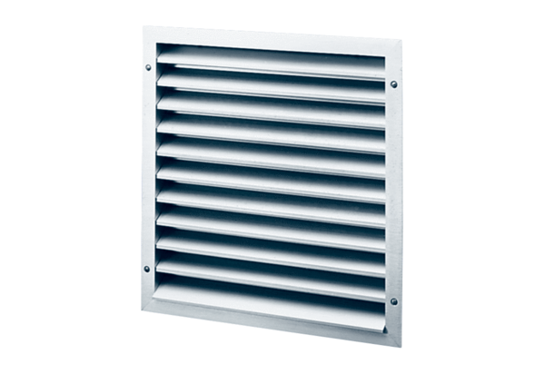External grille MLZ 25Packing unit: 1 pieceRange: C
Article number: 0151.0102Manufacturer: MAICO

