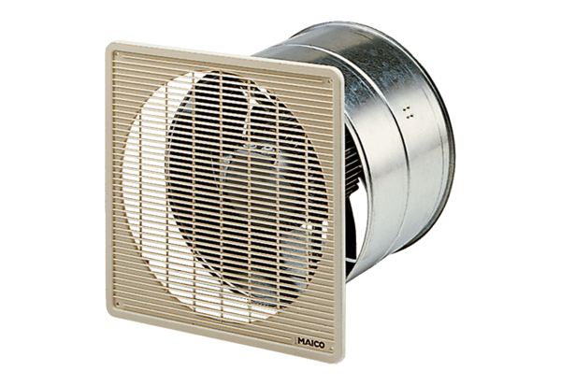EZF 35/4 BPacking unit: 1 pieceRange: C
Article number: 0085.0056Manufacturer: MAICO

