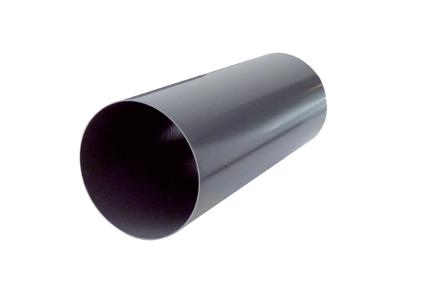Shell sleeve PP 60 RHLPacking unit: 1 pieceRange: K
Article number: 0059.0080Manufacturer: MAICO

